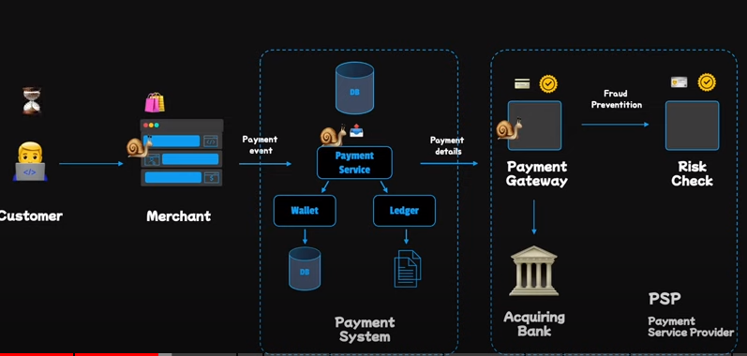

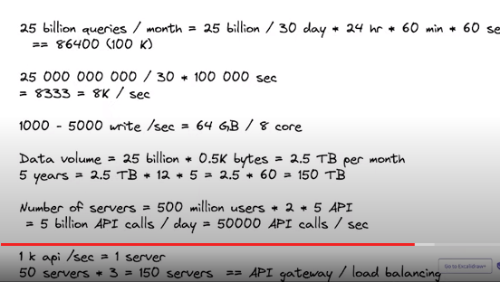

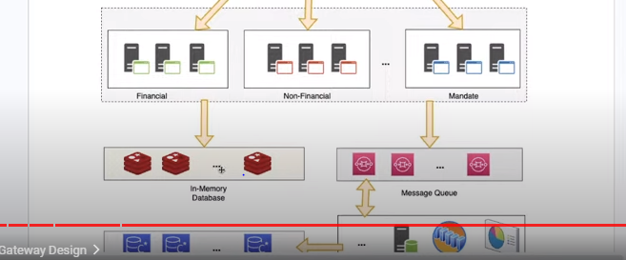

10 lakh = 1 million

100 lakh = 10 million

100 lakh = 1crore

1000 million = 100crore

1 billion = 100 crore = 100 x 100 lakh = 10000 lakh

So, 5 billion= 5 x 10000 lakh = 50000 lakh

1 terabyte = 1000000000 kilobyte

1 gigabyte = 1000000 kilobyte

1 gigabyte = 1000 megabyte

1 terabyte = 1000 gigabyte

1 kilobyte = 1000 bytes